**MID TERM III EXAMINATION - 2024**

**PRIMARY ONE- MATHEMATICS**

NAME: ___________________________________

STREAM: _______________________________

**INSTRUCTIONS:**

1. Read well and answer all questions.

2. You must write well.

3. Write correct spellings and answer in full sentences where necessary.

**SECTION A**

1. Take away

6 – 4 =_____

1. Write the shaded fraction

|  |  |  |
| --- | --- | --- |
|  |  |  |

_________

1. Write the word for the number

24 _____________________

1. Add:

3 6

+ 1 0

______

1. Write the number between

97, ____, 99

1. Write the number shown on the abacus

Tens Ones

1. Count in threes.

3, 6, ___, 12.

1. Add:

5 + 7 =

1. Tell the time.

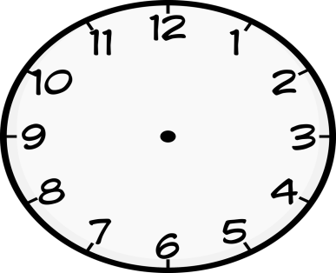 It is O’clock

1. How many sides has a triangle?

_________________________

1. Subtract:

6 5

- 2 3

______

1. Fill in the missing numbers.

80, 81, 82, ____, ____

1. Draw a set of 5 cars.
2. Write the place value of 7 in the figure below

7 3

1. Count in tens and ones.

_______ tens _____ ones = _______

1. Add the fractions.

+ =

1. Mercy had 12 dolls. She gave 2 dolls to her friend Sarah. how many dolls did she remain with?
2. Name the shape.

____________

1. Multiply:

5

X 3

____

1. Name the first day of the week.

__________________________

**SECTION: B**

1. Work out:

Tens Ones

3 2 4 3

+ 4 5 X 2

___________ _____

Tens Ones

6 8

- 1 2

________

1. Write the number symbols.

nineteen ______

forty six ______

b)Kato has 8 cups. Kiiza has 6 cups. How many cups do they have altogether?

1. Work out using a numberline.
2. 2 + 5 =
3. 9 - 4 =
4. Name the shaded fractions.

_________ ___ ______

b)Shade $\frac{1}{4}$

|  |  |
| --- | --- |
|  |  |
|  |  |

1. Show the working
2. Peter has 7 cakes. Sam has 6 cakes. How many cakes do they have altogether?
3. There are 2 eggs on each tray. How many eggs are there on 4 trays?
4. Racheal bought 7 glasses from the shop. 3 glasses got broken. How many glasses remained?
5. Write the names of the given ordinal numbers.

5th ____________________________

3rd ___________________________

1st _____________________________

1. Write any three days of the week
2. _______________
3. _______________
4. _______________
5. Count, write the number and its word.

______ ______________

______ ________________

______ ______________

1. Draw tens and ones for;
2. 33
3. 06
4. Complete correctly

5 tens 2 ones = ______

1. Find the missing numbers
2. Compare the sets

M N

1. Which set has 6 members?
2. Which set has less members?
3. How many members are in set M and set N altogether?
4. **Study the picture graph and answer the questions**

**Children playing with balls**

1. How many balls does Monica have?
2. Who has the most number of balls?
3. How many children are playing with balls?